Academic Year: 2026-27 Name of Student: Neev Rambhia
Semester: V Student ID: 25206010
Class / Div / Branch: T.E./ C / CSE(AI&ML) Roll No: 154
Subject: WMD Lab Date of Performance: 30/09/2026
Name of Instructor: Prof. Vijesh Nair Date of Submission: 14/10/2026

Experiment No. 9
Aim: Deploy Spring Boot app to a cloud platform (Render or Heroku) or local server.
Lab Outcomes: Apply microservices, REST APIs, and deployment techniques for scalable applications.
Software Used: Java JDK17 or above, Spring Boot, Maven, Git & Github Account, Render Account.
Program:
CommonComponents.jsx
import React from 'react';

export function Button(props) {
const {
children,
variant = 'primary',
size = 'md',
onClick,
type = 'button',
disabled = false,
className = '',
icon: Icon = null
} = props;

const baseClass = 'btn';
const variantClass = `btn-${variant}`;
const sizeClass = size !== 'md' ? `btn-${size}` : '';

return (
<button
type={type}
onClick={onClick}
disabled={disabled}
className={`${baseClass} ${variantClass} ${sizeClass} ${className}`.trim()}
>
{Icon && <Icon className="btn-icon" size={16} />}
<span>{children}</span>
</button>
);
}

export function Badge(props) {
const { children, type = 'default', className = '' } = props;
return (
<span className={`badge badge-${type} ${className}`.trim()}>
{children}
</span>
);
}

export function PageHeader(props) {
const { title, subtitle, action } = props;
return (
<div className="page-header">
<div className="page-header-text">
<h1 className="page-title">{title}</h1>
{subtitle && <p className="page-subtitle">{subtitle}</p>}
</div>
{action && <div className="page-header-action">{action}</div>}
</div>
);
}

export function SectionHeader(props) {
const { title, subtitle, action } = props;
return (
<div className="section-header">
<div>
<h2 className="section-title">{title}</h2>
{subtitle && <p className="section-subtitle">{subtitle}</p>}
</div>
{action && <div className="section-action">{action}</div>}
</div>
);
}

export function LoadingState(props) {
const { message = 'Loading campus data...' } = props;
return (
<div className="state-box">
<div className="loading-spinner"></div>
<h3 className="state-title">Fetching Data</h3>
<p className="state-message">{message}</p>
</div>
);
}

export function EmptyState(props) {
const {
icon: Icon = null,
title = 'No Records Found',
description = 'There are no items matching your criteria.',
action = null
} = props;
return (
<div className="empty-state">
<div className="empty-icon-wrapper">
{Icon ? <Icon size={32} /> : '📋'}
</div>
<h3 className="empty-title">{title}</h3>
<p className="empty-description">{description}</p>
{action && <div style={{ marginTop: '1.25rem' }}>{action}</div>}
</div>
);
}

export function ErrorState(props) {
const { title = 'API Connection Error', message, onRetry, onSwitchMock } = props;
return (
<div className="state-box error-box">
<h3 className="state-title">{title}</h3>
<p className="state-message">{message}</p>
<p className="error-tip">
Please check your internet connection or verify that the Fixora API backend service is running.
</p>
<div className="error-actions">
{onRetry && (
<button onClick={onRetry} className="btn btn-primary btn-sm">
Retry REST API Connection
</button>
)}
{onSwitchMock && (
<button onClick={onSwitchMock} className="btn btn-secondary btn-sm">
Use Static mockData.js
</button>
)}
</div>
</div>
);
}

Dockerfile
# ==========================================
# Fixora Backend Dockerfile
# Multi-stage build for Spring Boot on Render
# ==========================================

# Stage 1: Build with Maven
FROM eclipse-temurin:21-jdk AS build
WORKDIR /app

# Copy Maven wrapper and pom.xml first (layer caching)
COPY .mvn/ .mvn/
COPY mvnw pom.xml ./

# Download dependencies (cached layer)
RUN chmod +x mvnw && ./mvnw dependency:resolve -B

# Copy source code and build
COPY src/ src/
RUN ./mvnw clean package -DskipTests -B

# Stage 2: Runtime image
FROM eclipse-temurin:21-jre
WORKDIR /app

# Copy the built JAR
COPY --from=build /app/target/campusfix-backend.jar app.jar

# Render sets the PORT env variable
EXPOSE ${PORT:-8080}

# Run with Render's PORT
ENTRYPOINT ["java", "-jar", "app.jar"]

IssueController.java
package com.campusfix.controller;

import com.campusfix.model.Issue;
import com.campusfix.service.IssueService;
import org.springframework.http.HttpStatus;
import org.springframework.http.ResponseEntity;
import org.springframework.web.bind.annotation.*;

import java.util.List;
import java.util.Map;

@RestController
public class IssueController {

private final IssueService issueService;

public IssueController(IssueService issueService) {
this.issueService = issueService;
}

// ==================== ROOT & HEALTH CHECK ====================

@GetMapping("/")
public ResponseEntity<Map<String, Object>> root() {
return ResponseEntity.ok(Map.of(
"service", "Fixora Spring Boot REST API",
"status", "UP",
"endpoints", List.of("/api/health", "/api/issues")
));
}

@GetMapping({"/api/health", "/health"})
public ResponseEntity<Map<String, String>> healthCheck() {
return ResponseEntity.ok(Map.of(
"status", "UP",
"service", "Fixora Spring Boot Backend",
"message", "Fixora API is running successfully"
));
}

// ==================== ISSUE CRUD ENDPOINTS ====================

// GET /api/issues or /issues — Fetch all issues
@GetMapping({"/api/issues", "/issues"})
public ResponseEntity<List<Issue>> getAllIssues() {
List<Issue> issues = issueService.getAllIssues();
return ResponseEntity.ok(issues);
}

// GET /api/issues/{id} or /issues/{id} — Fetch single issue
@GetMapping({"/api/issues/{id}", "/issues/{id}"})
public ResponseEntity<Object> getIssueById(@PathVariable Long id) {
return issueService.getIssueById(id)
.<ResponseEntity<Object>>map(ResponseEntity::ok)
.orElse(ResponseEntity.status(HttpStatus.NOT_FOUND)
.body(Map.of("error", "Issue not found")));
}

// POST /api/issues or /issues — Create new issue
@PostMapping({"/api/issues", "/issues"})
public ResponseEntity<Issue> createIssue(@RequestBody Issue issue) {
Issue created = issueService.createIssue(issue);
return ResponseEntity.status(HttpStatus.CREATED).body(created);
}

// PUT /api/issues/{id} or /issues/{id} — Replace entire issue
@PutMapping({"/api/issues/{id}", "/issues/{id}"})
public ResponseEntity<Object> updateIssue(@PathVariable Long id, @RequestBody Issue issue) {
return issueService.updateIssue(id, issue)
.<ResponseEntity<Object>>map(ResponseEntity::ok)
.orElse(ResponseEntity.status(HttpStatus.NOT_FOUND)
.body(Map.of("error", "Issue not found")));
}

// PATCH /api/issues/{id} or /issues/{id} — Partial update
@PatchMapping({"/api/issues/{id}", "/issues/{id}"})
public ResponseEntity<Object> patchIssue(@PathVariable Long id, @RequestBody Issue patchData) {
return issueService.patchIssue(id, patchData)
.<ResponseEntity<Object>>map(ResponseEntity::ok)
.orElse(ResponseEntity.status(HttpStatus.NOT_FOUND)
.body(Map.of("error", "Issue not found")));
}

// DELETE /api/issues/{id} or /issues/{id} — Delete issue
@DeleteMapping({"/api/issues/{id}", "/issues/{id}"})
public ResponseEntity<Object> deleteIssue(@PathVariable Long id) {
if (issueService.deleteIssue(id)) {
return ResponseEntity.ok(Map.of("success", true, "id", id));
}
return ResponseEntity.status(HttpStatus.NOT_FOUND)
.body(Map.of("error", "Issue not found"));
}
}

Output:
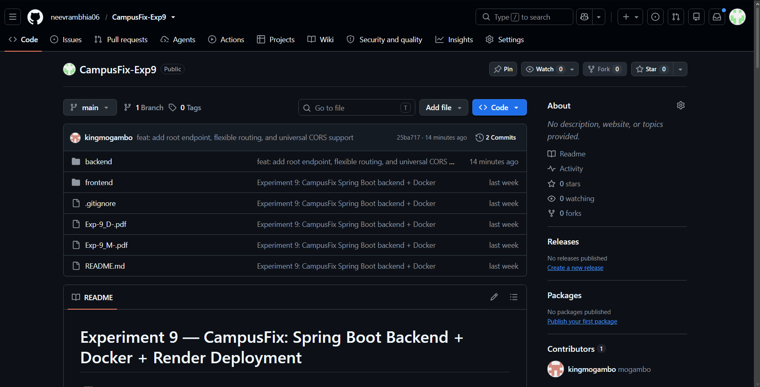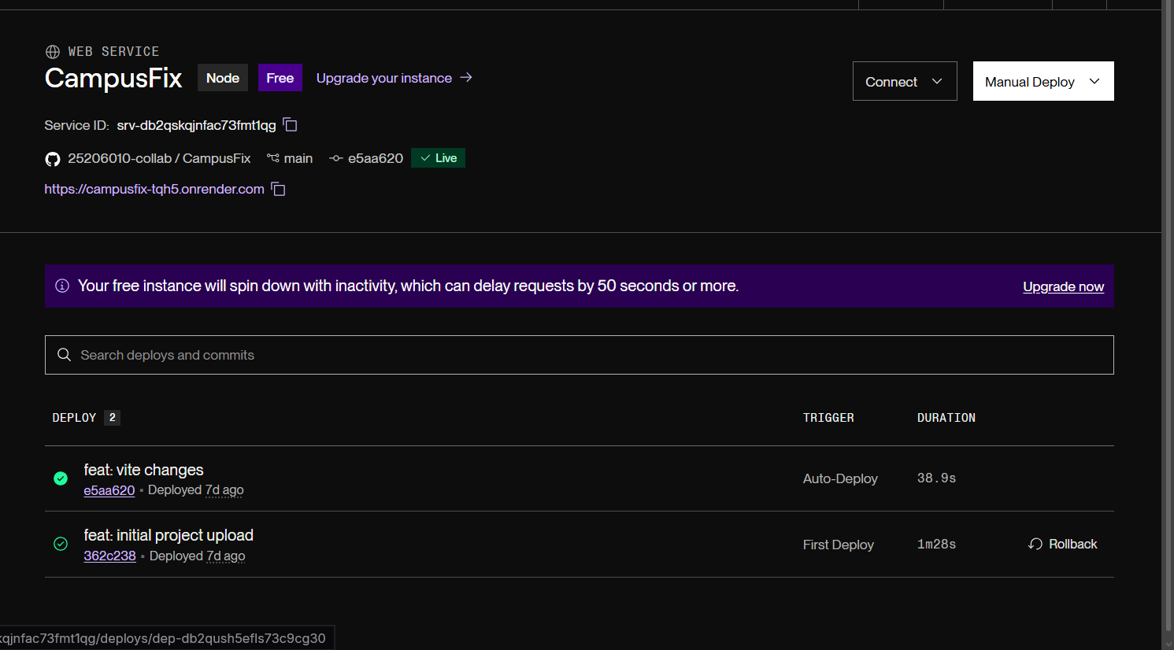
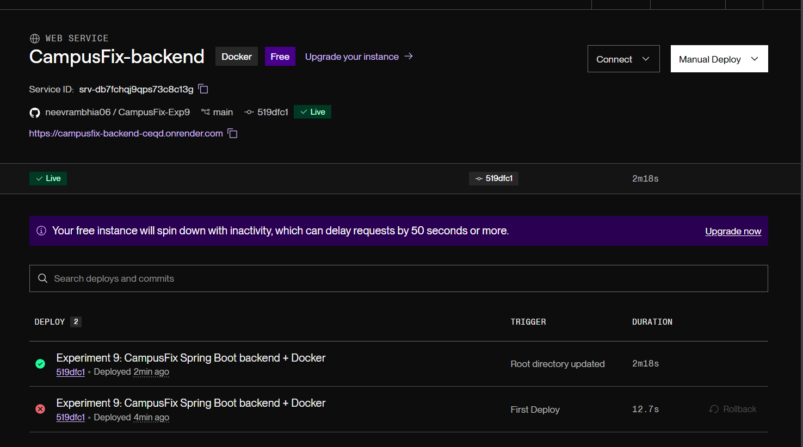
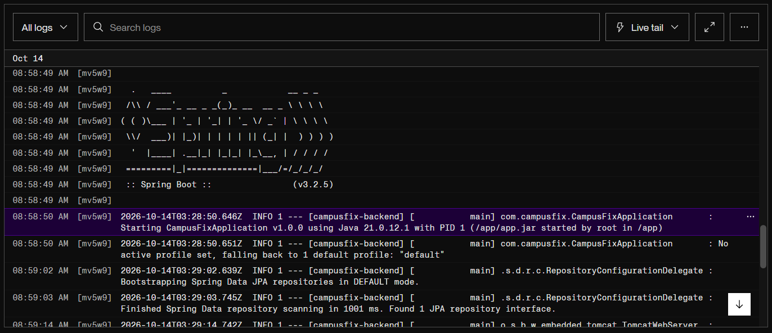
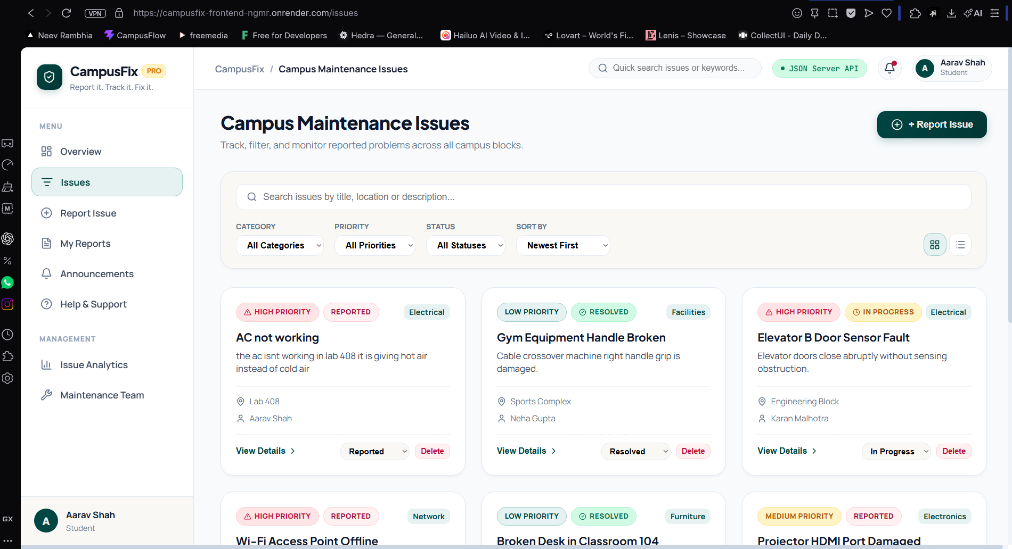
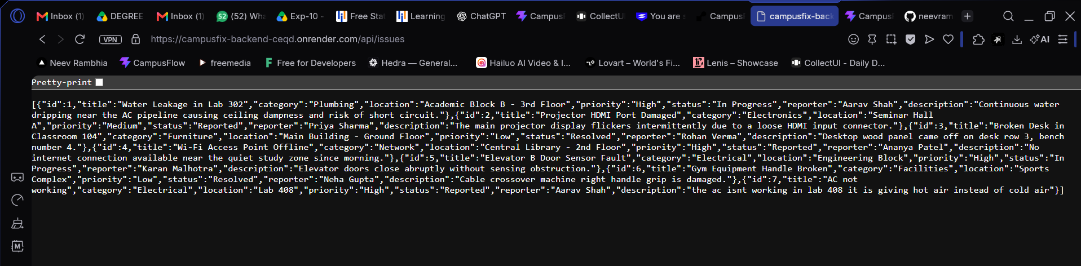

Conclusion: Thus, we demonstrated and deployed Spring Boot application to a cloud platform called Render.

